**ELEN 4720: Machine Learning for Signals, Information and Data**

Homework #4

Rakshith Kamath (rk3165)

December 12, 2021

**Problem-1 (Markov Chains)-35 Points**

1. Use wt to rank the teams by sorting in decreasing value according to this vector. List the top 25 team names (see accompanying file) and their corresponding values in wt for t = 10,100,1000,10000.

The top 25 teams at t=10,100,1000 and 10000 are as shown below:

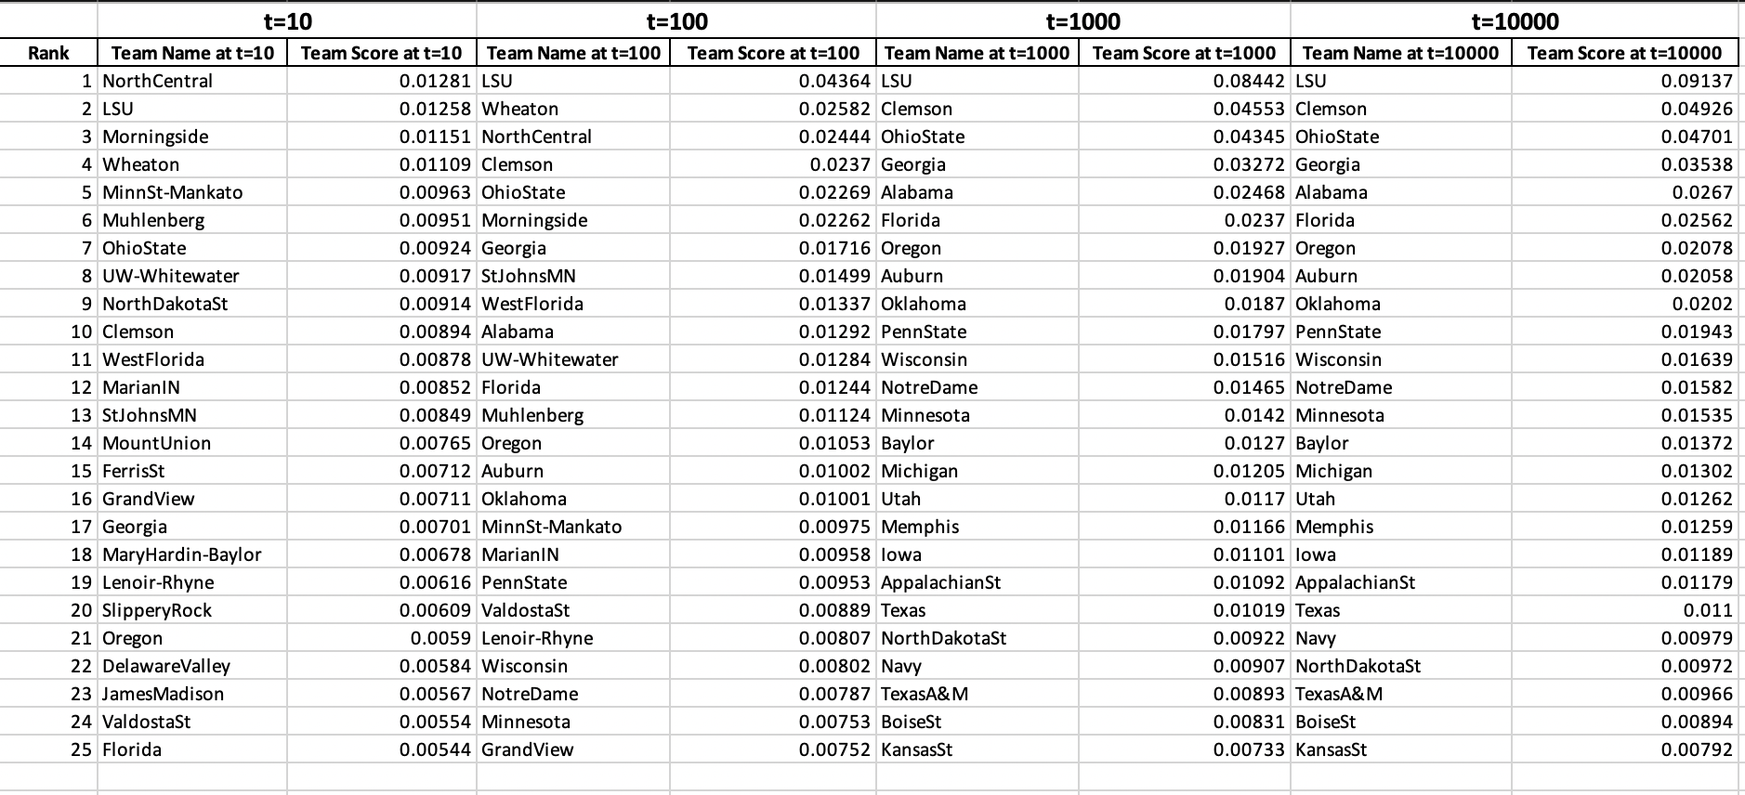

Table 1- Top 25 teams for different iterations

1. Plot the || wt - winf ||1 as a function of t for t =1,2,…..,10000.

The plot of first order norm between wt and winf is shown below-

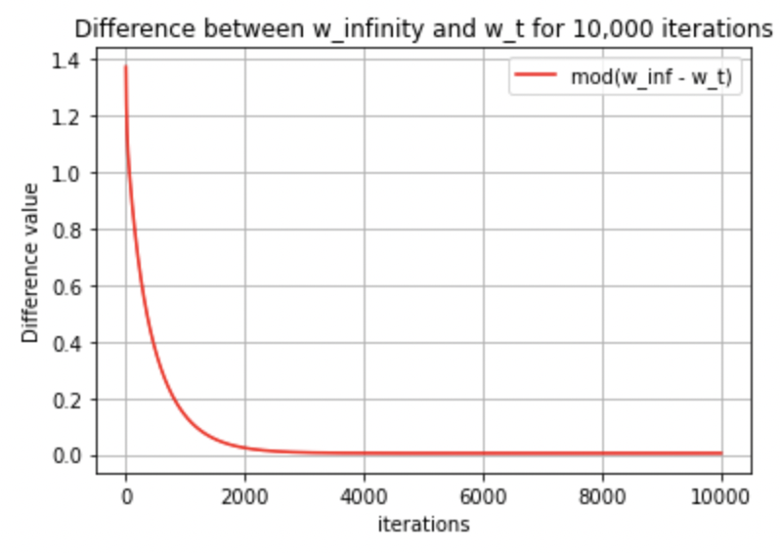

Figure 1 – Plot of difference between wt and winf for carious iterations

**Problem-2 (Non-Negative Matrix Factorization)-40 Points**

1. Implement and run the NMF algorithm on this data using the divergence penalty. Set the rank to 25 and run for 100 iterations. This corresponds to learning 25 topics. Plot the objectives as a function of iteration.

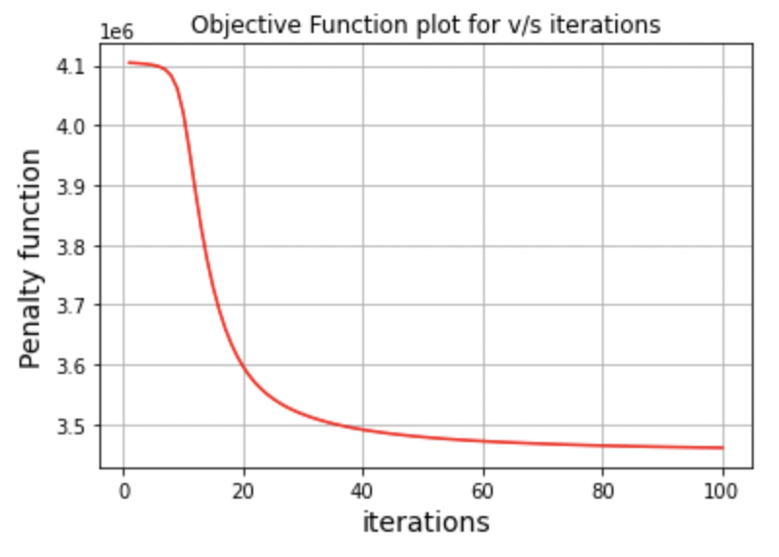

Figure 2- Plotting the objective functions for various iterations

1. After running the algorithm, normalize the columns of W so they sum to one. For each column of W, list the 10 words having the largest weight and show the weight. The ith row of W corresponds to the ith word in the dictionary provided in the data. Organize these lists in a 5x5 table. Each iteration and run gives different lists and one of them is shown below-

